Scenario 1: Web Service based integration through SOAPUI for **PSLedLocation**

We are trying to verify the Location details for a particular employee(ANZ_LANID🡪rustagis) in PeopleSoft as below:

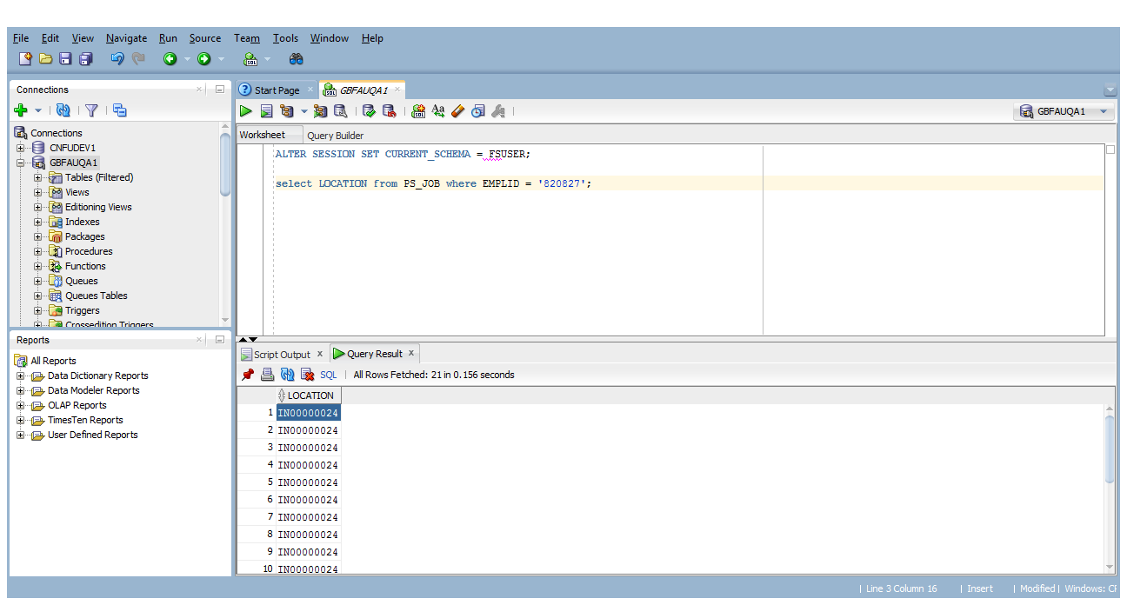

Navigate to the below path:

Main Menu🡪People Tools🡪Integration Broker🡪Integration Setup🡪Service

Search for the “ANZ_EMPLOYEE_LOCATION” service as below:

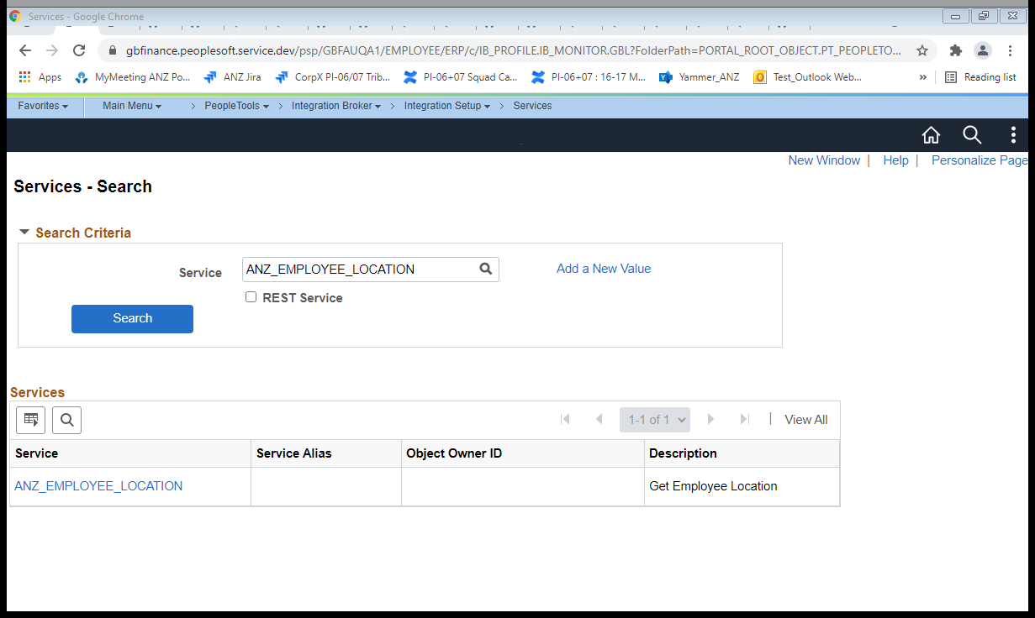

Click on Service Hyperlink

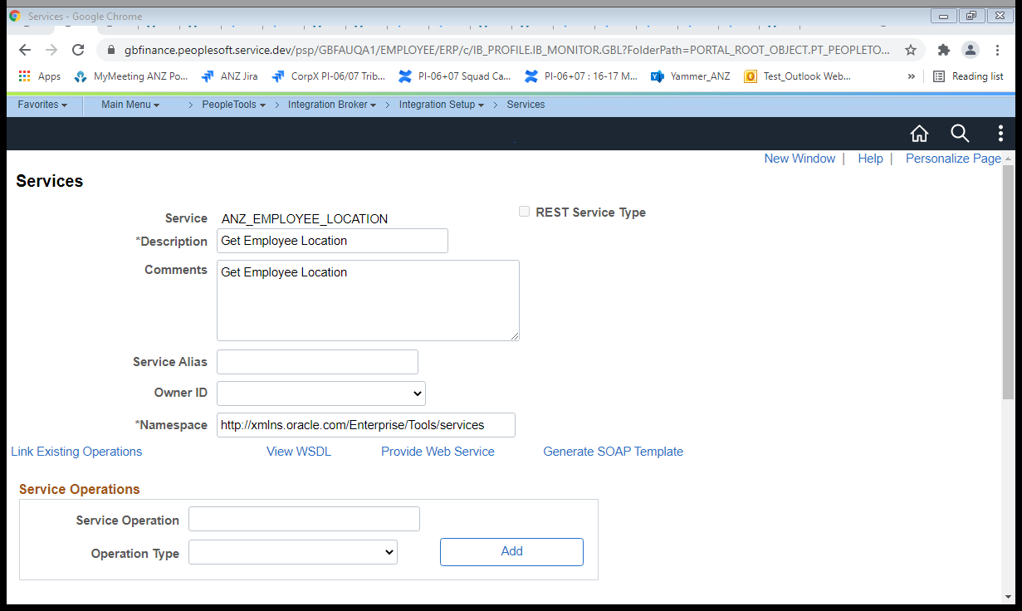

Click on View WSDL link

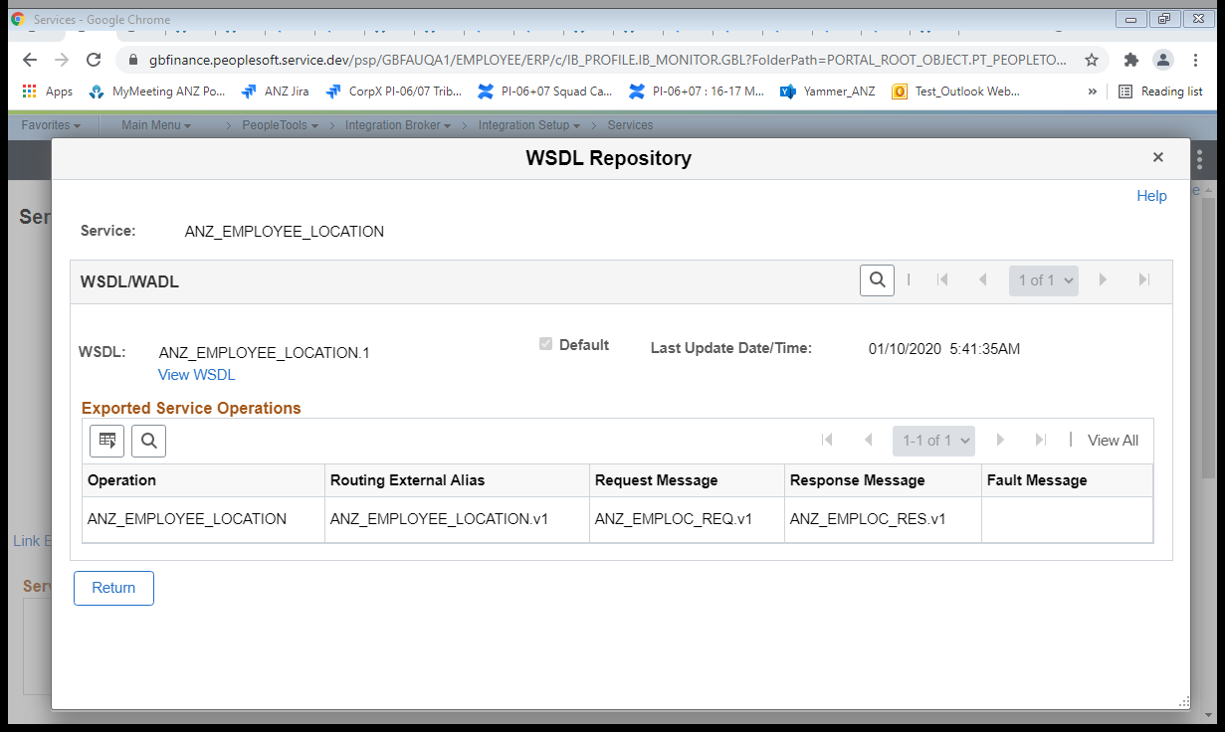

Click on View WSDL link

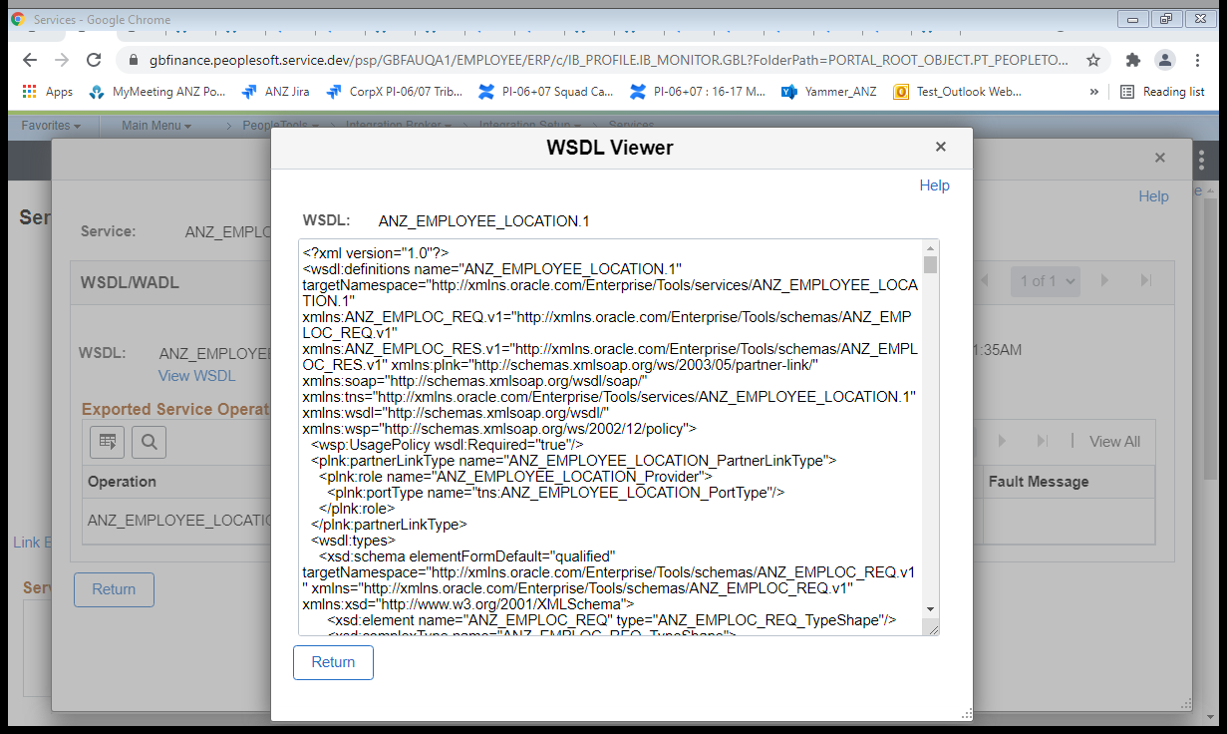

Copy the WSDL completely and save it as an .wsdl extension file as shown below:



Try loading the wsdl file in the soapUI with a project(PSLedLocation) created as shown below

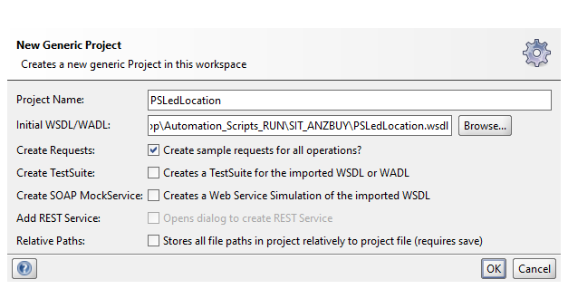

Click on OK Button and update the "EMPLID” as “820827” and “ANZ_LANID” as “rustagis” as below

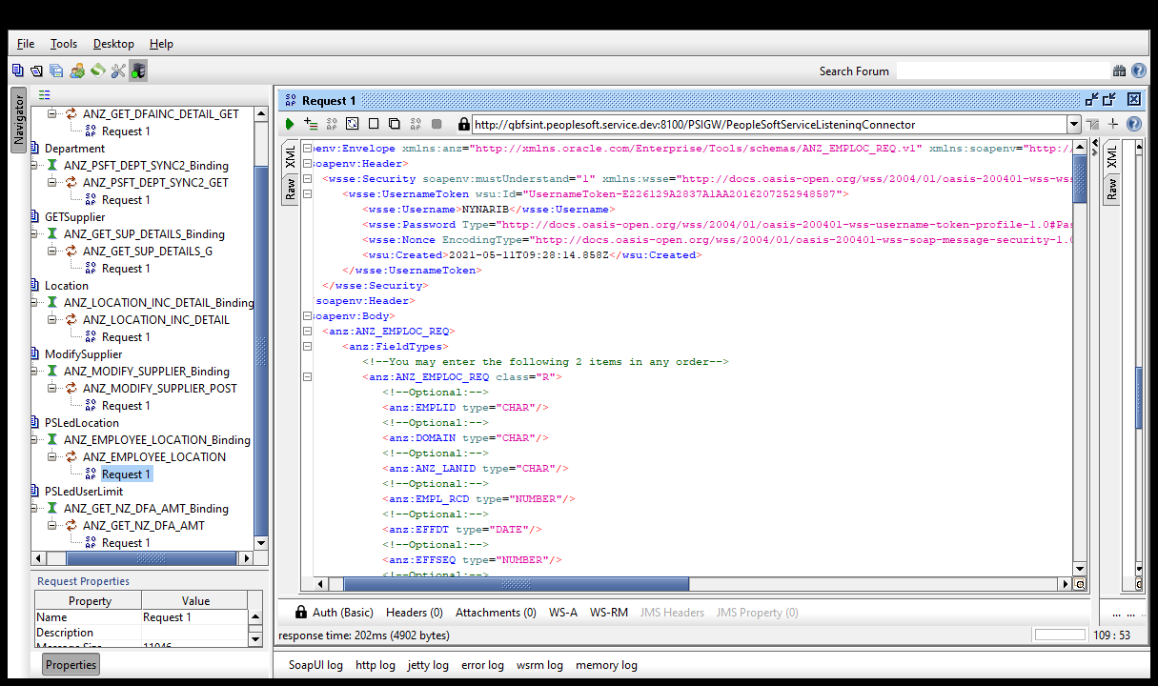

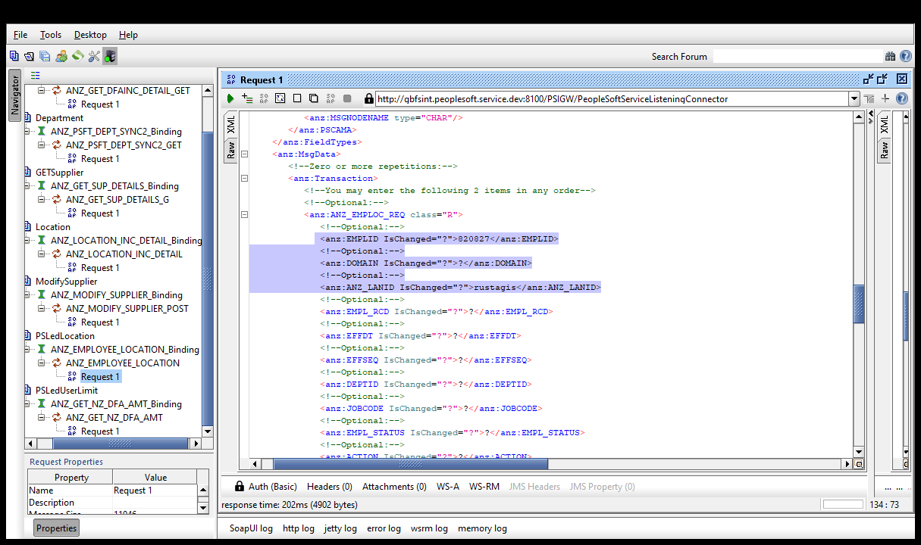

Click on “Auth” and enter the credentials and select the New authorization as shown below

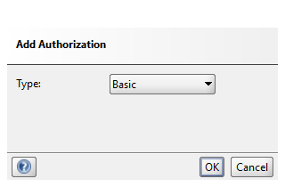

Click on OK Button

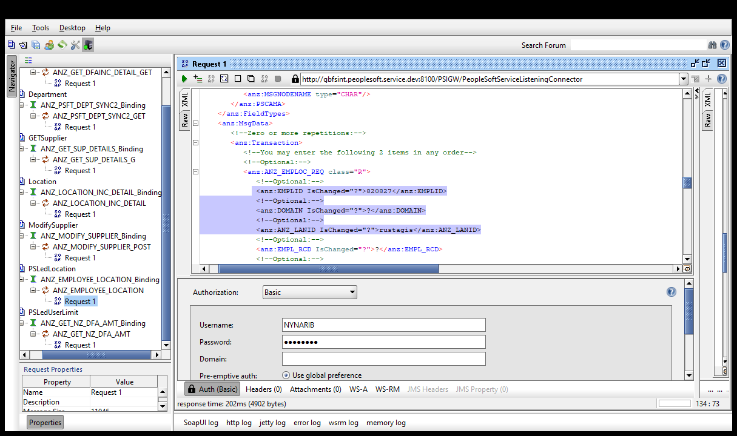

Right Click on the request tab and Click on “Add WSS Username Token” and select it as “PasswordText” as below

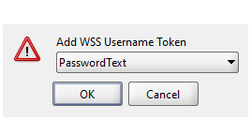

Click on “Submit request to specified endpoint URL”

Verify the Response with the correct Location details as below

